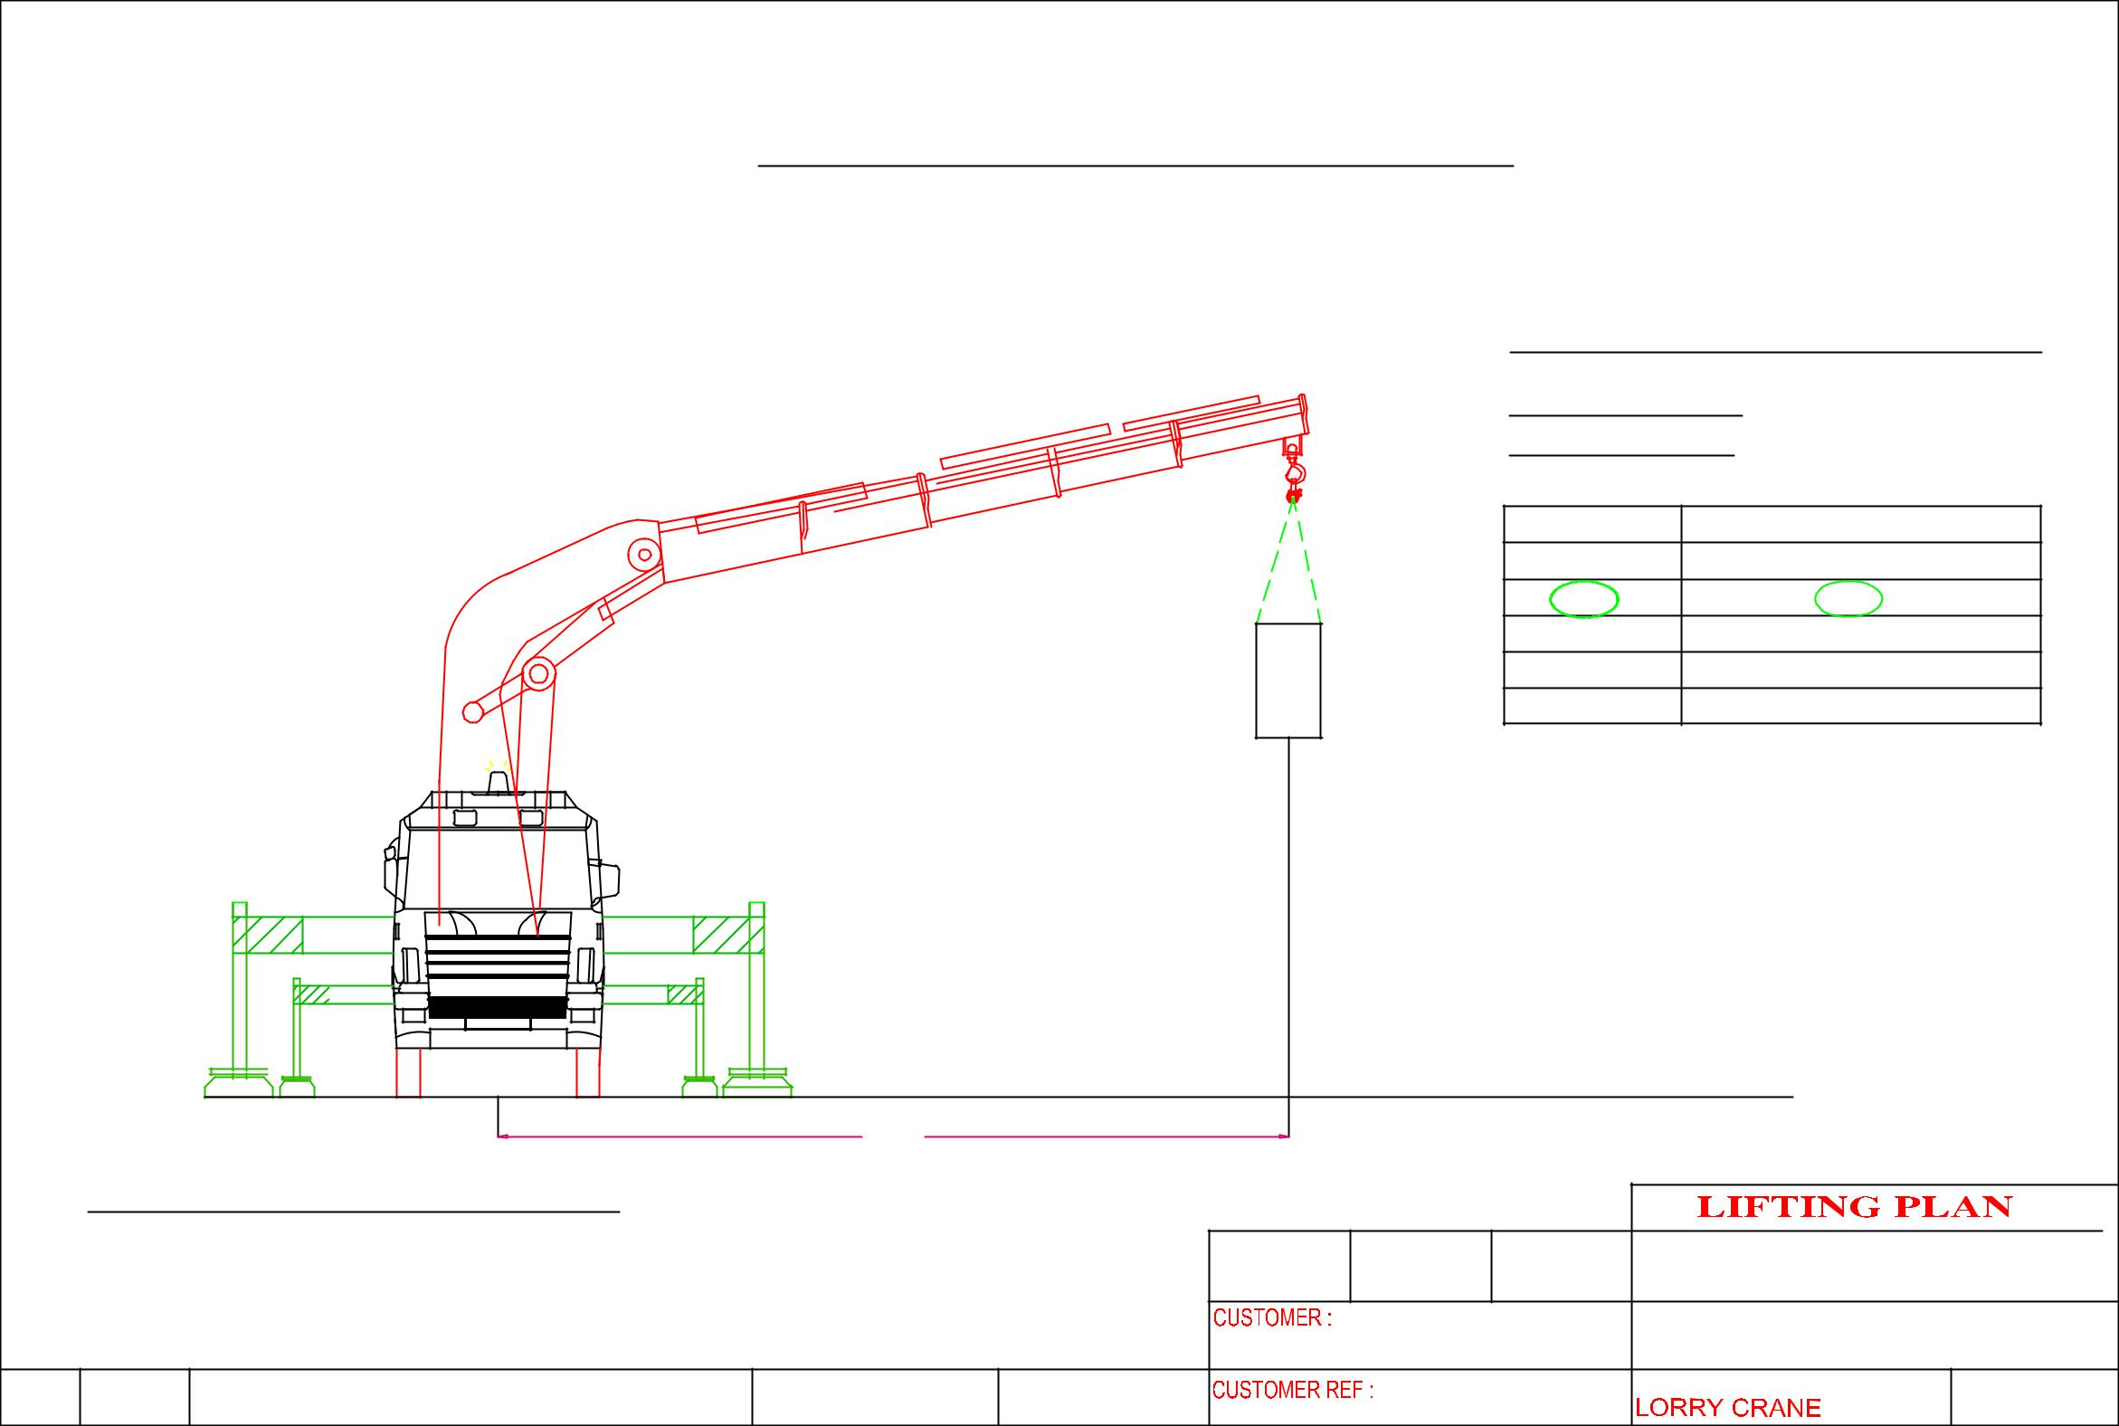
 |  |  | HOISTING OF MACHINE AT 2nd FLOOR
 |  |  |  |  |  |  |  | CRANE :PALFINGER PK100002F
 |  |  |  |  |  |  |  | LORRY CRANE
 |  |  |  |  |  |  |  | CRANE CONFIGURATI0N
 |  |  |  |  |  | m6 |  | OPERATING RADIUS : 8m
 |  |  |  |  |  |  |  | ^{OPT . RADIUS(m)} |  | LIFTING CAPACITY OF CRANE IN KG
 |  |  |  |  |  |  |  | 4 |  |  | 17, 840
 |  |  |  |  |  |  |  | 6 |  |  | 10, 900
 |  |  |  |  |  |  |  | 8 |  |  | 8, 600
 |  |  |  |  |  |  |  | 10 |  |  | 7, 000
 |  |  |  |  |  |  |  | 12 |  |  | 5,000
 |  |  |  |  | MACHINE WEIGHT: | 1,000 KG |  | SAFETY FACTOR CALCULATION
 |  |  |  |  |  |  |  | WEIGHT OF CARGO |  |  | : 1,000 KG
 |  |  |  |  |  |  |  | LIFTING ACCESSORIES WEIGHT : 2, 500 KG
 |  |  |  |  |  |  |  | TOTAL WEIGHT OF LIFTING |  |  | : 3, 500 KG
 |  |  |  |  |  |  |  | LIFTING CAPACITY |  |  | :8, 600 KG
 |  |  |  |  |  |  |  | SAFETY FACTOR |  |  | : 2.457 KG
 |  |  |  | 8M
 | CRANE :PALFINGER PK100002F
 |  |  |  |  |  | DRAWN | APPROVED | DATE | ERIC WONG MACHINERY TRANSPORTATION P/L
 |  |  |  |  |  |  | Energy Press  Pte Ltd |  | DRAWING NAME:
 |  |  |  |  |  |  |  |  | HOISTING OF MACHINE

